**Hip Radio – Revamp**

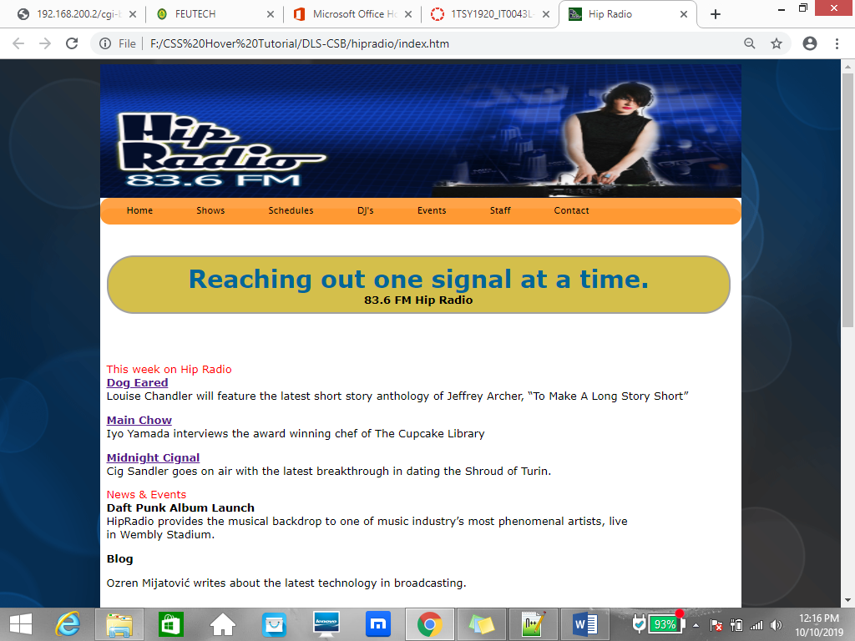

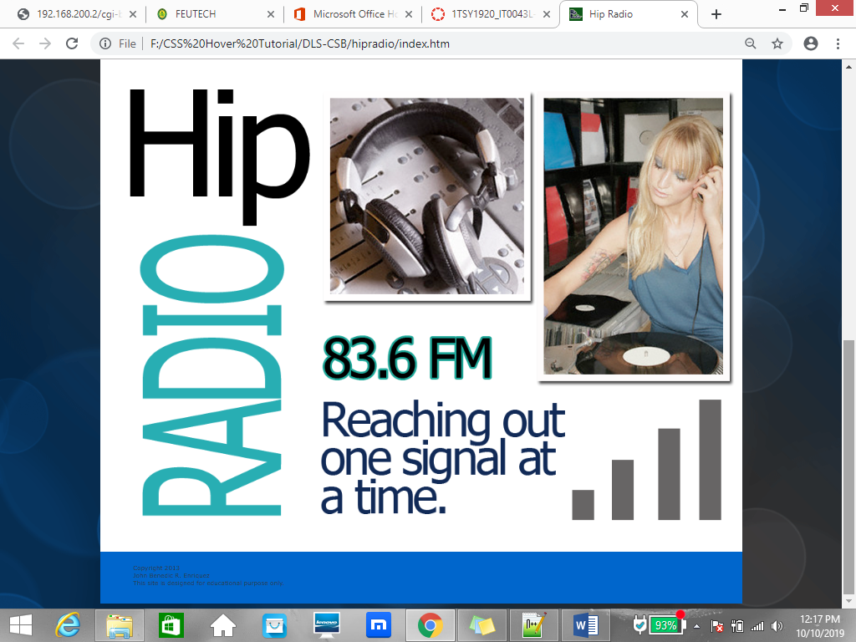

**HOME**

This week on Hip Radio  
**Dog Eared**  
Louise Chandler will feature the latest short story anthology of Jeffrey Archer, “To Make A Long Story Short”

**Main Chow**  
Iyo Yamada interviews the award winning chef of The Cupcake Library

**Midnight Cignal**  
Cig Sandler goes on air with the latest breakthrough in dating the Shroud of Turin.

News & Events  
**Daft Punk Album Launch**  
HipRadio provides the musical backdrop to one of music industry’s most phenomenal artists, live in Wembly Stadium.

**Blog**

Ozren Mijatović writes about the latest technology in broadcasting.

**SHOWS**

College Radio - Mondays 19:30 – 20:30

Ken Jenkins brings us behind the scenes in college life. Weekly, Ken interviews different school organizations across the country to share with us the latest hip activities. The show employs streaming Skype connections from different colleges. Ken is has a Social Arts degree specifically on college interactivity, surely his expertise will bring out the best in this show.

Dog Eared - Tuesdays 18:00 – 18:30

Louise Chandler reviews the latest hip books in the market today. Louise, who is an accomplished writer herself having written three bestsellers, takes us through the important facets of each book she reviews. You will be amazed at how she can open up prose for us to understand and appreciate even more. J.K. Rowling calls her the Harry Potteress of fantasy.

Main Chow - Wednesdays 14:00 – 15:00

Iyo Yamada takes us around the city one restaurant at a time. Most of the time she reviews places that are worth mentioning, but in some rare occasion she brings to the studio special guests and chefs of these gastronomic establishments for an interview.  
  
Finishing her culinary degree at Fountain Bleu in Paris, Iyo has her own very well attended restaurant called The Goose Station which serves everything goose.

Midnight Cignals - Thursdays 22:30 – 01:00

Cig Sandder is big on paranormal, psychic, and just plain weird phenomena and makes him the best person to host this show about everything peculiar. Cig comes from several generations of UFO hunters and debunkers. It was his father who proved that crop circles were faked and propelled their family to international fame. In his show, Cig accepts phone calls which should make for very interesting entertainment for late owls.

The Dating Game - Fridays 19:00 – 21:00

Franz Yanez hosts this show about love and love problems. The first hour of the show is devoted to answering emails and letters; while the second hour (or whatever is left of the show) is dedicated to phone in questions.   
  
Having worked five years in clinical psychology, Franz has been helping people with relationship problems. No concern is too obscure nor unimportant for her. Even if you don’t have a concern, just listening in will warm your heart.

Traffic Watch - Everyday  7:00, 12:00, and 17:00

Louise Chandler and her crew of helicopters updates you with the latest traffic flow in the city. For the .past ten years, Louise has been giving helpful traffic advice and alternatives. A group of helicopters fly around the city to aid in bringing you up-to-the-second information.

**SCHEDULE**

Create your own Time Table / Schedule.

**DJ’s**

The station is popular because of DJ Twinkle. When Twinkle was a younger lad he used to play this game with his friends. The “it” would record an hour’s worth of music and the listeners would try to guest the name of the song. If  someonegot the title of any song right, the “it” would have to continue his role. If no one got any of the song titles, a new “it” was pre-selected. So the more obscure the music, the better for the “it”. This is what made DJ Twinkle a phenomenon: that was so well rounded with music.  
  
The station owners, now including Global Communications, dedicate a slot for him and he can play anything he wants. This is how much trust they have on him.

Heather, better known by her air-name Lady Luck is a maverick in both station and off-station events. Her wit and dexterity with sound instruments makes her a much coveted DJ.  
  
Coming from the Netherlands, where her air-name was The Ice Queen, she won the Sverige National DJ championship where tens of thousands of DJs around the world participated. Heather outplayed them all for 72 hours without skipping a beat, literally.

Andrew is known as the Emo Boy of the sound waves. His droll is quite entertaining, actually, and is a very sought after voice for commercial voice-overs. Andrew started off with Warner Brothers as an advertisement foley artist. His opportunity came when one day the voice talent did not appear for an important recording. Andrew auditioned for the part and without batting an eyelash, got the position, replacing the old voice-talent forever.

Lilithe is a diehard new age practitioner. You can hear her chimes and tubular bells on the air which she brings with her to the booth every single day (she says they keep her luck.)  
  
The outstanding thing about Lilithe is her smooth swan voice. Among a thousand people who auditioned to do the voice of the Japanese animated series Princess Hasegawa, when the producers heard her, she was hired on the spot.

Mark has got the be the most electrifying DJ ever. His energetic voice and style will sure perk everyone up. Although his other job is DJing at night in local pubs, he does the early shows on Hip Radio because of his pep.  
  
When asked how long does he sleep before he goes on air, he says he doesn’t. He says he just reads the latest news online and prepares for his morning show. Of course he says he sleeps the rest of the day until his night shift.

Jay comes from generations of voice-talents. His mother, in fact, was the great Vanessa George who was the darling of the silver screen for many years. Being wired to do this, nothing much can stress him out, and which is why he seems calm all the time – thus getting the name Stoic.  
  
The great thing about his voice is that anyone listening to him also calms down. For this reason, the station managers always put his slot after the traffic news.

**EVENTS**

**DAFT PUNK ALBUM RELEASE**

**GIRL TALK**

**NEON BRIT**

**WHITE PARTY**

**STAFF**

**Saara Husskonsen**

Station Manager  
Ever since Saara was a girl she was always fascinated with radio broadcasting. This wasn’t a surprise as her father was the station manager of the Royal Radio in Sweden. Following her father’s footsteps, Saara manages the most coveted radio station today.

**Zayd Wajeeh Hasalem**

Master Broadcast Engineer  
Zayd is a wiz when it comes to sound. He can find solutions to any concern very much with any equipment available. This is why Global Communications poached Zayd from a competitor station and made him the master broadcast engineer of Hip Radio.

**Ozren Mijatović**

Technical Specialist  
Ozren is the technical guy to run to when you need someone for sound. His knowledge of sine waves and other not-for-laymen knowledge is his specialty. He can clean any interference or feedback, and that’s what makes him important in the industry.

**Yu Chiang**

Booth Manager  
Every DJ needs a booth manager to guide them through the glass wall. Yu makes a very good manager owing to his vast and deep experience with several stations prior to Hip Radio. His claim to fame is that his shows precisely start and end on time. That is a claim not every booth manager can make.

**Charles Duffield**

Master Sound Specialist  
Charles is a wonder when it comes to broadcast engineering. He can tackle set-ups and dismantling in a jiffy. His organized workflow makes him a stalwart contender in today’s fast-paced lifestyle. Because of this, Charles is head of every event the station partakes of

**CONTACT**

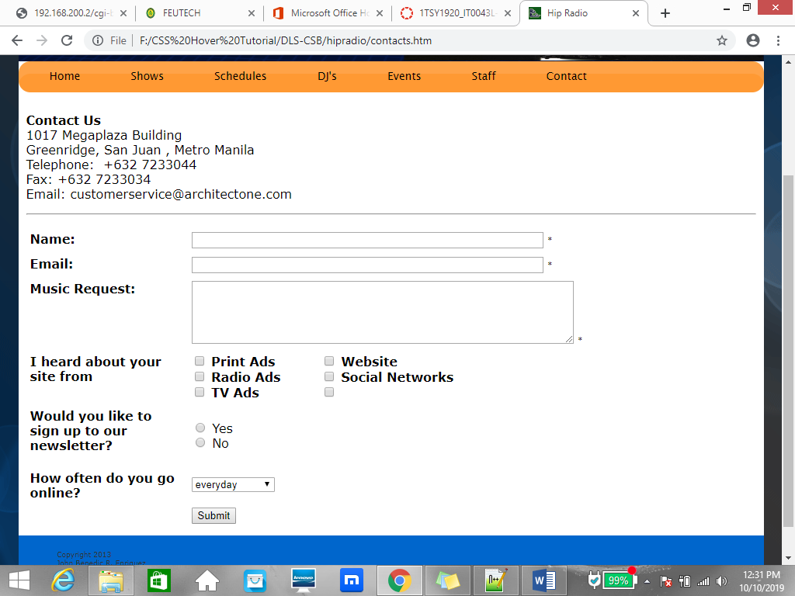

Use the School address and Room for the Address.

**REFERENCES**

Include all References here(sources came from On-line, like images, audio, etc). Create an additional page for this.